
Khulna University
Computer Science and Engineering Discipline
Title of the Course: Electronic Devices and Circuits Sessional
Course No: 071402 ECE 2152

Name of the Experiment: Frequency and Phase Response of Low Pass Filter and High Pass Filter.

Submited to:
Dr. Md. Mahbub Hossain  Professor  Electronics and Communication Engineering Discipline  Khulna University, Bangladesh | Dr. Md. Ziaul Amin  Professor  Electronics and Communication Engineering Discipline  Khulna University, Bangladesh

Submitted by:
Kazi Rifat Morshed
Student ID: 230220
2nd year, 1st term
Computer Science and Engineering Discipline
Khulna University, Bangladesh

Date : 24 October 2024
Khulna University
Computer Science and Engineering Discipline
Title of the Course: Electronic Devices and Circuits Sessional
Course No: 0714 02 ECE 2152

Name of the Experiment:
Frequency and Phase Response of Low Pass Filter and High Pass Filter.

Objectives:
After completion of this experiments, we learnd the characteristics of Low Pass Filter and High Pass Filter through analysis of frequency and phase response.

Theory:
A filter is a circuit consists of RLC components or electronic components (such as transistors, op-amps etc.) that selects or rejects a band of frequencies. A Low Pass Filter allows to pass frequencies below cut-off frequency. On the other hand, A High Pass Filter allows to pass signals above cut-off frequency.

Required Devices and Instruments:
In this experiment, we need a digital graph plotting software like Matlab or GNU Octave to plot the responses in logarithmic scale.

Circuit Diagram:
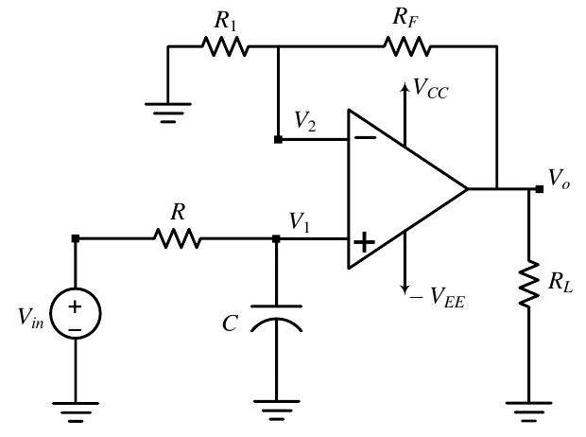
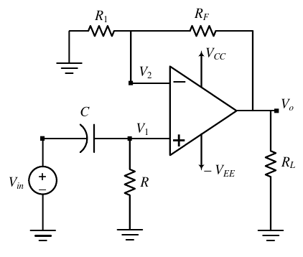
Figure 01: Circuit Diagram of First Order Active Low Pass Filter.
Figure 02: Circuit Diagram of First Order Active High Pass Filter.

Experimental Procedure:
After fixing cut-off frequency and the value of the capacitor, values of resistors were determined and then Passband Gain of the Filter, A_{F} was calculated. For both LPF and HPF, and Phase Angle,θ was plotted using respective formulas.

Experiments and Records:

Cut-off frequency, f_{c} = 10 kHz
C = 0.01 x 10⁻⁶ F
R_{F} = = = 15915.45 Ω = 15.915 kΩ
R₁ = R_{F} = 15.915 kΩ
Passband Gain of the Filter, A_{F} = = 2
For Low Pass Filter:
Voltage Gain for LPF,

where, n is the order of the filter.

So, Voltage Gain for LPF in dB,
and, phase angle, θ_{LPF} =

For High Pass Filter:
Voltage Gain for HPF,

where, n is the order of the filter.

So, Voltage Gain for HPF in dB,
and, phase angle, θ_{HPF} =

The Matlab code for plotting frequency response of LPF:
R_F = 15915; % R1 = R_F = 15.915 kΩ
R_1 = 15915; % R1 = R_F = 15.915 kΩ
f = [0:10:100000];
order = [1:1:5];
f_c = 10000; % cut off frequency
A_F = 1 + (R_F / R_1);
colors = ['r', 'g', 'b', 'm', 'k'];

hold on;
grid on;

% Low Pass Filter
xlabel('f (Hz) (Logarithmic Scale)')
ylabel('20 log(V_o/V_in) (Logarithmic Scale)')
title('Frequency Response of a LPF from 1st to 5th order');

for i = 1:5
V_out_by_V_in_LPF = A_F ./ sqrt(1 + ((f ./ f_c) .^ (2 * i)));
y_axis_LPF = 20 * log10(V_out_by_V_in_LPF);
loglog(f, y_axis_LPF, colors(i));
end

legend('Order 1', 'Order 2', 'Order 3', 'Order 4', 'Order 5');
hold off;

The Matlab code for Phase Response of LPF:
f = [0:10:100000];
f_c = 1000; % cut off frequency
grid on;
hold on;

% Low Pass Filter
xlabel('f (Hz) (Logarithmic Scale)');
ylabel('Magnitude(in Degree)');
title('Phase Response of LPF');

y_axis_LPF = -atand(f ./ f_c);
semilogx(f, y_axis_LPF);

hold off;
The Matlab code for plotting frequency response of HPF:
R_F = 15915; % R1 = R_F = 15.915 kΩ
R_1 = 15915; % R1 = R_F = 15.915 kΩ
f = [0:10:100000];
order = [1:1:5];
f_c = 10000; % cut off frequency
A_F = 1 + (R_F / R_1);
colors = ['r', 'g', 'b', 'm', 'k'];

hold on;
grid on;

% High Pass Filter
xlabel('f (Hz) (Logarithmic Scale)')
ylabel('20 log(V_o/V_in) (Logarithmic Scale)')
title('Frequency Response of a HPF from 1st to 5th order');

for i = 1:5
V_out_by_V_in_HPF = A_F ./ sqrt(1 + ((f_c ./ f) .^ (2 * i)))
y_axis_HPF = 20 * log10(V_out_by_V_in_HPF);
loglog(f, y_axis_HPF, colors(i));
end

legend('Order 1', 'Order 2', 'Order 3', 'Order 4', 'Order 5');
hold off;

The Matlab code for Phase Response of HPF:
f = [0:10:100000];
f_c = 1000; % cut off frequency
grid on;
hold on;

% High Pass Filter
xlabel('f (Hz) (Logarithmic Scale)');
ylabel('Magnitude(in Degree)');
title('Phase Response of HPF');

y_axis_LPF = atand(f_c ./ f);
semilogx(f, y_axis_LPF);

hold off;

Result:
The output figures are:
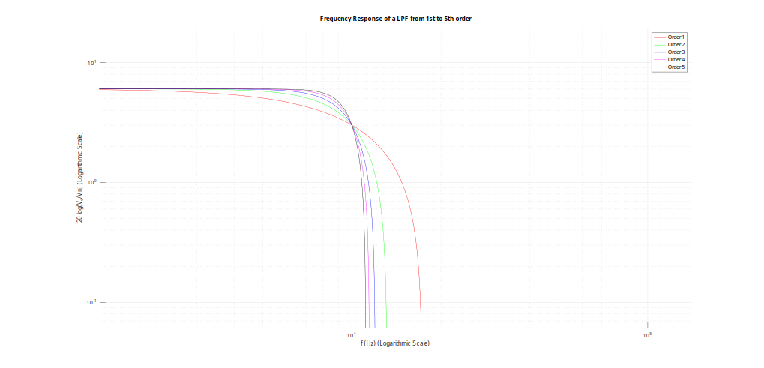
Figure 03: Frequency Response of LPF from 1st to 5th order.

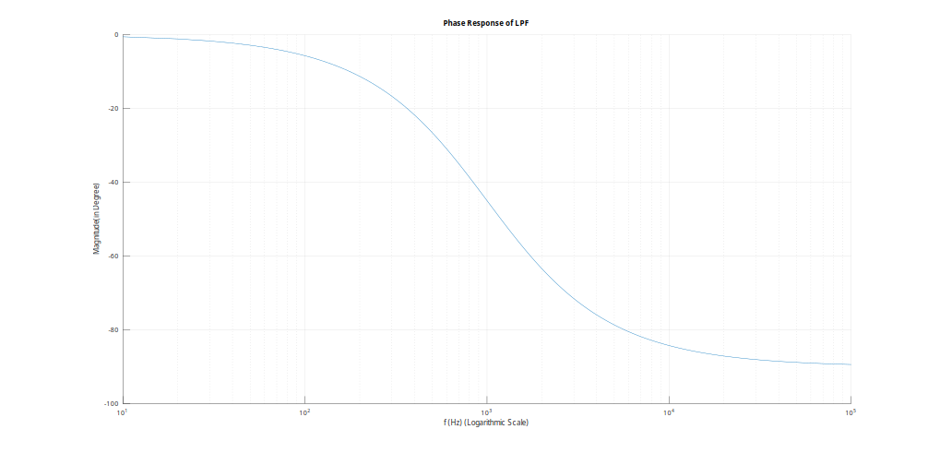
Figure 04: Phase Response of a 1st Order LPF.
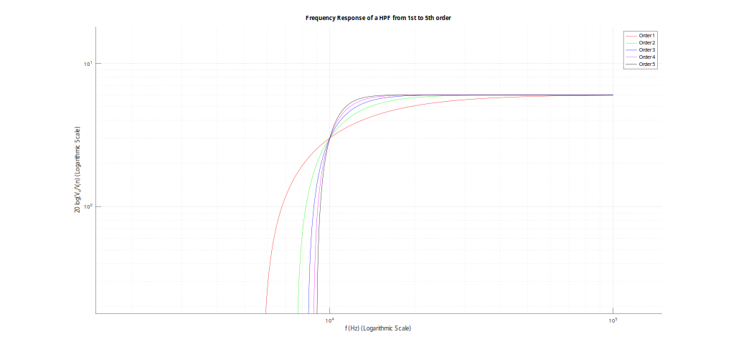
Figure 05: Frequency Response of HPF from 1st to 5th order.
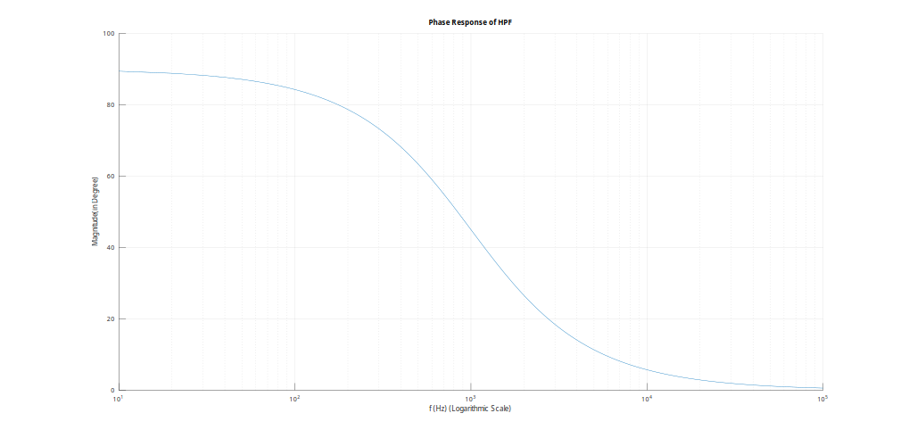
Figure 06: Phase Response of a 1st Order HPF.

Discussion:

Frequency Response of LPF from 1st to 5th order:
Frequency response of LPF graph was plotted where frequency, f (Hz) was in logarithmic scale in x-axis and Voltage Gain (dB) was in logarithmic scale in y-axis. The graph was plotted for 5 different LPF from order 1 to 5, resulting in 5 curves. These 5 curves intercept each other in a point where f = f_{c} and Voltage gain is 3dB less than maximum value. As the order of LPF increases, the curve becomes sharp, achieving characteristics of an ideal filter.
When the frequency is less than f_{c} , the value of V_{out}/V_{in} is almost equal to A_{F}

